Anomaly Detection In Online Games Using Unsupervised Machine Learning Algorithms

By
ONIFADE EKUNDAYO
(ID: W20450627)

Supervised by
NICHA KANDASAMY

Submitted in partial fulfilment of the requirement of
the School of Computer Science & Engineering
of the UNIVERSITY OF WESTMINSTER
for award of the Master of Science
In
Data Science & Analytics


January 2025
DECLARATION
I, ONIFADE EKUNDAYO, declare that I am the sole author of this Project, that all references cited have been consulted, that I have conducted all my work of which this is a record, and that the finished work lies within the prescribed word limits.

This has not previously been accepted as part of any other degree submission.

Signed:…………………………………………………………………………………..

Date:………………………………03/01/2025………………………………………

FORM OF CONSENT
I, ONIFADE EKUNDAYO, hereby consent that this Project, submitted in partial fulfilment of the requirements for the award of the MSc degree, if successful, may be made available in paper or electronic format for inter-library loan or photocopying (subject to the law of copyright) and that the title and abstract may be made available to outside organisations.

Signed:…………………………………………………………………………

Date:…………………………03/01/2025…………………………………
Table of Contents
ABSTRACT 6
1. INTRODUCTION 7
1.1 BACKGROUND TO THE STUDY 7
1.2 STATEMENT OF THE PROBLEM 8
1.3 AIM OF THE PROJECT 10
1.4 OBJECTIVES 10
Understanding: 11
Application: 11
Analyse: 11
Evaluation: 11
1.5 SCOPE OF THE STUDY 11
1.6 MOTIVATION OF THE STUDY 12
1.7 CHAPTER SUMMARY 13
2. LITERATURE STUDY/REVIEW 14
2.1 INTRODUCTION 14
2.2 REVIEW OF EXISTING PAPERS 14
2.3 CONCEPTUAL REVIEW 16
2.3.1 K-MEANS CLUSTERING 16
2.3.2 ISOLATION FOREST 18
2.3.3 ANOMALIES 18
1. POINT ANOMALIES 18
2. CONTEXTUAL ANOMALIES 19
3. COLLECTIVE ANOMALIES 19
4. SUPERVISED ANOMALY DETECTION 19
5. SEMI-SUPERVISED ANOMALY DETECTION 19
6. UNSUPERVISED ANOMALY DETECTION 19
2.3.4 CHEATING & ANTI-CHEAT METHODS 20
DEFINITION OF CHEATING 20
1. CHEATING IN ONLINE MULTIPLAYER GAMES 20
2. CHEATING IN ESPORTS 21
2.4 CHAPTER SUMMARY 21
3. RESEARCH METHODOLOGY 23
3.1 PROPOSED APPROACH 23
Tools and Technologies 24
3.2 PROPOSED APPLICATION PROCEDURES 25
Dataset Acquisition 25
General information of Dataset 26
Dataset Wrangling 26
Understanding Results 28
3.3 CHAPTER SUMMARY 29
4. IMPLEMENTATION AND RESULT 30
4.1 UNSUPERVISED ML ALGORITHM APPLICATION 30
4.2 UNSUPERVISED ML ALGORITHM VISUALISATION & DETECTION 31
Isolation Forest Visualisation 31
K means Visualisation 34
4.3 RESULTS AND FINDINGS 35
4.3.1 Isolation Forest 35
4.3.2 K means Clustering 36
4.4 SUMMARY 36
5. CONTRIBUTION TO KNOWLEDGE 38
5.1 LIMITATIONS OF STUDY 38
5.2 RECOMMENDATION FOR FURTHER STUDY 39
5.3 EVALUATION & CONCLUSION 39
6. REFERENCES 40
7. APPENDIX 42

ABSTRACT
In the video game sector, cheating is becoming a rampant problem that is destroying the competitiveness and integrity of online video games. Cheats are becoming more intricate and incredibly hard to spot. At the same time, research and progressive works on anti-cheats are things of secrecy in the community to protect their cutting-edge advancements and not provide cheat creators with valid ways to counteract them. With the application of supervised machine learning algorithms, each video game must have a tuned and specific algorithm to detect specific cheats, bots, scripts and injectors, but with the application of an unsupervised machine learning algorithm catered to detect anomalies, such application would be faster and much broader. Anomaly detection has come into play for an extended period in identifying and extracting anomalous components from data. Various techniques have been used, and one of the most efficient techniques is Machine Learning (ML), which is pivotal in this area. This thesis focuses on applying anomaly detection to a cleaned and normalised chess dataset to pick up and identify anomalies. Detection of anomalies using unsupervised ML modes is a promising area of research in online video games. This thesis hopes to prove the usefulness of unsupervised ML and its realistic applications.
Index Terms Anomaly detection, machine learning, cheating, chess, multiplayer, video games and unsupervised algorithms.

1. INTRODUCTION

1.1 BACKGROUND TO THE STUDY
Online video games originally came into being as a form of entertainment but have now transformed into an integrated communication and entertainment system in a playful, competitive, computer-mediated environment that evolves through human interaction, according to Guo Freeman, 2017 [1]. As an entertainment medium, video games have not only gained substantial popularity within recent years, but the online video game industry has spawned a much more competitive scene, which has led to various competitions hosted amongst the best players in the world competing for large amounts of money across multiple games in a sport referred as electronic-sports also called e-sports. Although this sport is heavily regulated by each gaming body, cheating, especially in online video games, is still a prevalent issue. Cheat developers and cheat users have grown to become such a force in the online video game community that various anti-cheat developers are subsequently employing machine learning algorithms to keep up with the pace of large exploits ruining the integrity and fairness of the sport.
The market size of the video game markets varies from one source to the next, but one could make a bold estimation that in the year 2022, the value was above 200 billion USD and is anticipated to grow to above 650 billion USD by 2030. A lot of factors contribute to such earnest growth, and one key aspect is accessibility. The ease of access to online video games has facilitated a massive network of highly sophisticated, networked, multimedia and multimodal internet technology, which has helped construct an entertaining, simultaneous, persistent social virtual world for gamers in accordance with Guo Freeman 2017 [1].
This thesis aims to examine unsupervised machine learning algorithms and their application in discovering anomalies in video game datasets. With the increase in complex exploits and activities, there is an excellent need for adaptive detection methods.
In the field of machine learning (ML), anomaly detection is regularly used in different domains, and it also helps identify malicious exploits more efficiently than other software-oriented technologies.
Exploits and cheats for video games are shared over various private platforms, which are moderated and usually behind a paywall. Such exploits are also shared amongst networks of cheats who sometimes have friends who might not be cheating, but due to social mechanisms, cheating behaviour has a high likelihood of spreading from cheaters to friends who play fair based on the number of cheating friends they have in accordance to Jeremy Blackburn et al. [2]. These platforms, which vary from online forums to online chat groups, are tight-knit communities which share knowledge and trade products and services, similar to other online communities focused on illicit and even illegal activities. An interesting fact is that cheaters in communities are highly likely to lose friends when they get labelled as cheats on public forums and gaming platforms, according to Jeremy Blackburn et al. [2]. Various online communities exist, and their sole purpose is to share cheating programs, exploits, and injection tutorials for the latest updates to video game services. Due mainly to the illegal manner of said activities, these platforms are shrouded in extreme secrecy.
With various advancements in the use of Machine Learning, research has shown that exploits are not used singularly. ‘Injectors’ or ‘loaders’ (usually used in part with exploits or scripts) are used to insert their cheats into the game memory, according to Panicos Karkallis et al. 2021 [3]; identifying the injectors could provide game developers with an edge in preventing the use of exploits and allow game developers to update detection capabilities of their respective anti-cheating system quickly. This thesis will not cover injectors but will focus solely on anomaly detection and unsupervised machine-learning algorithms. However, it is something of interest that should be pointed out.

1.2 STATEMENT OF THE PROBLEM
A significant problem online multiplayer games continue to face is the loss of integrity, finances, and competitiveness due to cheats and exploits, which ruin the experience of players who put in a lot of effort to attain a certain level of skill. The effort, time and monetary commitment players put into the games is instantly endangered because of the influence cheats can have on the outcome of games, taking away the control from players' skills, intelligence and hard-earned capacity to win games. Also, cheats deconstruct the manner in which said video games are programmed by the developers to be interacted with. Multiple game platforms have created various ways to protect their individual games from the influence of cheats and exploits; most involve some form of player report system to assist. With the adoption of anomaly detection with an unsupervised system, the reliance on player-based reported/flagged games would significantly reduce, which could lead to a much faster and quicker ban on cheaters.
In the case of Valve, a game developer of various prominent games like Counter-Strike, Half-Life, Team Fortress, etc., employs an anti-cheat tool called Valve Anti-Cheat (VAC), which is also a component of the Steam gaming platform. Steam is an online gaming platform that allows players to not only purchase video games, usually on a personal computer, but also create a social network of friends or groups by sending friend requests or invites. These groups of friends can interact with each other through the possession of similar games or an online chat feature. The exact details and inner workings of VAC software are hidden. As such, open discussion could lead software developers to write code, reverse engineer, or social engineer as a way to evade its application. In theory, Valve relies on reports of players who report other players they suspect of cheating. Also, VAC takes note of previous cheats in its index/codex and instantly bans players who have similar or the same exploits on their systems. This process is called Signature Scanning, as it detects possible cheats by going through the computer's processes and other subsequent memory parts to detect previously known cheats. This process is not instantaneous and is sure to affect some players' experience. In cases where players are even reported, it takes a process as submissions sometimes be reviewed by engineers, which often takes weeks to months to ban cheaters; such delay already has a considerable impact on the player base and the commitment to learning the game mechanics.
Riot, the developers of League of Legends, took a more open stance on preventing cheaters from ruining the experience of other gamers on their platform. In the case of League of Legends, two types of cheats are most prominent. Scripting is a third-party program that attaches itself to the game client and uses the client’s memory and functionality to attempt to accomplish difficult or otherwise impossible tasks, as reported by Riot on their site. Botting is also a third-party application, but this, in turn, simulates gameplay input to give some semblance of random gameplay or human interactions with the client. Each of these cheats serves a purpose with scripting providing the player with an edge to compete at a higher skill level by performing complex skills, gaining in-game client information like range of abilities or zoom (perception) hack while botting is aimed at levelling new accounts faster or a means to allow a bot to acquire an in-game item through repeated but tedious actions like playing multiple games in a row or using a specific in-game character numerous times. Riot Games built their entire prevention methods on a strong philosophy that involved deterrence, prevention, and detection. This process works in an everlasting cycle. The Basic concepts of what they try to implement are as follows:
They ensure their executable codes (codes that influence the in-game character movements and actions, network connection and reveal of other in-game characters) are encrypted on the game client, which is decrypted on their server. This blocks injectors from just taking hold of the game's actual code and injecting bots or scripts to be executed in the game. Another step Riot takes is to randomly input debuggers during bootstrap to block the injected script from running; each subsequent bootstrapping randomises the checkpoint and which file is being checked for fraudulent activity. This openly discussed method has seen Riot's anti-cheat methods come under scrutiny by cheat developers and developers alike. In addition to these methods, Riot also uses a submission and report system for gamers to report in-game cheats, a widespread practice among video game platforms and companies. Such reports are then first processed to find similarities between known exploits in the index. If that is not the case, Riot engineers will analyse it. Regardless, once the cheat has been injected into the game/client layer, reports in bringing attention to said cheaters take time, and that time reduces the game's integrity and the game's competitive nature.
Chess.com is arguably the most used online multiplayer chess gaming platform. They have not only hosted numerous in-person chess contests but have also hosted a continuous line of online contests, which are free for everyone with a chess.com account to join. Chess.com has taken numerous steps to ensure that its platform not only lives up to the rigorous integrity of the in-person games, which have referees, mediators, and cameras scrutinising each move made by every player. Online games have no such luxury, so to maintain a similar level of integrity and to prevent players from using exploits and cheating, chess.com has taken on various levels to secure and deter players from such means. One key advantage Chess.com has is its large dataset of games, which pulls in games played in-person and in competitions and pulls in online games from high and low Elo equally. These games are then inputted into a machine-learning algorithm shrouded in extreme secrecy. This machine learning algorithm pulls on the rank of the players, the time it takes for the player to make their moves, their previous playstyle, strategy and move-set and how similar their move is to a chess engine-generated move-set. The specifics of how their algorithm is tuned, calibrated or trained are not made public, but a few pieces of information are. Chess.com maintains a database of flagged games; these games are ones in which a player reported their opponent for acting in an irregular manner, either by using a chess engine to suggest the best possible move-set or due to their high level of accuracy, which does not match their given Elo rank. One such manner of dealing with online cheats is similar across multiple platforms. These flagged games are, in turn, fed into their machine-learning algorithm. Also, a fair play team critically analyses flagged games. Fair play team members are seasoned chess veterans and understand what to look for. The final and key component that brings this all together is analysing for move accuracy (stated earlier), timing of the move and historical data comparisons of the player and their opponent. Paying attention to unique or abnormal moves that deviate from the standard style of play or natural pattern. All these put together ensure Chess.com’s anti-cheat system is more often than not up to standard, but the details behind the machine learning algorithm remain a mystery.
Anomaly detection, on the other hand, can easily detect gameplay mechanics that defer from the usual gameplay method of any in-game mechanics, placing a ban or a shadow ban on accounts which exhibit a form of evasion from the standard or perceived way of interacting with other in-game characters. This would not only cut down the time it takes to catch cheaters but would also give other players a more substantial reliance on the fact that cheaters on their platforms are constantly under surveillance, and once an anomaly is detected, said cheaters would quickly be removed from the game or in the very least be removed from interacting with other players until they are either found guilty or innocent.

1.3 AIM OF THE PROJECT
Anomaly detection has been applied to various other aspects ranging from healthcare to finance and fraud detection. Various unsupervised anomaly detection algorithms from K Means to Isolation Forest have found successful applications in said fields with relatively positive outcomes. In this thesis, an analysis of an online game of chess between white and black focuses on one of the major problems of online chess games, which is the use of third-party applications to provide highly accurate moves for a player whose Elo ranking should mathematically not be able to attain, with the application of third-party applications like stockfish, an open-source chess engine. Player B, who has a lower Elo rating and is more likely to lose, would have a superior but illegally attained edge, and this not only ruins the credibility of the Elo ranking system but also destroys any means of trust in the competitiveness of online multiplayer games. A successful anomaly application in chess would swiftly pick up on the use of a chess engine to bypass the Elo ranking system and skill level difference between the two players. Also, the use of cheats in a game would be swiftly recognised and reported to the respective authorities. The thesis aims to find the proper application of anomaly detection algorithms in the world of online multiplayer, especially chess, to predict the usage of open-source chess engine applications or another anomaly that does not perform according to the Elo ranking system. One should note that occasionally, players could exhibit skills or talents far superior to their current rank, but such should not be the norm as that would either represent a player of high skill playing under a wrong Elo rank or another player impersonating a lower-ranked Elo player.

1.4 OBJECTIVES
This thesis focuses on using unsupervised machine learning algorithms to detect anomalies in a chess game dataset. In this case, K means Clustering and Isolation Forest. This unsupervised machine learning algorithm should be able to cluster correctly or group games in which the user of the white pieces cheat, black pieces cheat or both cheat while being able to group games where none of the players cheat. The hyperparameters of the unsupervised algorithm should be tuned to show progress in clustering and anomaly detection. This system should be able to detect cheats as anomalies regardless of each player's moves in the game, as the system is not a chess-based engine. The system should be able to correctly cluster the large chess dataset in sections while taking into account the results, Elo rating of players and the suspected cheat moves and colour of players. The objective of this project was to detect anomalies in online multiplayer games initially, but due to the lack of available datasets which includes games where cheats and exploits were used to gain an advantage, the thesis pivoted to use a chess dataset on Kaggle and apply the unsupervised machine learning algorithm to detect anomalies in the dataset.
Understanding: The most important objective of this project is to gain a high-level insight into online multiplayer games and anomaly detection practices. Upon research of online multiplayer games and cheating in video games, it is apparent that game developers rely strongly on the community to report cheats and exploits, and more often than not, this is the most prevalent way to catch cheats. Also, most research into this field depended on perfect knowledge of the particular gaming environment and the malicious anomaly to be detected, which is usually not the case in real-life scenarios as cheat developers are constantly updating and evolving their exploits. It is worth noting that the extreme secrecy of this field has created a research gap in the subject of cheat detection, which limits the availability of reliable datasets and research notes from developers, which in turn forces each game developer to develop their own cheat detection system for their game. There have been numerous ways of detecting cheats in video games, which include but are not limited to player behaviours and their interactions with the platforms ranging from various applications of player behaviour ranging from mouse movements to multimodal interactions between players and platforms transformed into multivariate time series, finding potential for mouse movement dynamics to measure player behaviour, Interval Bound Propagation (IBP) in detecting frame buffer’s to detect illicit overlays, historical data comparisons to name a few. This shows the multiple ways researchers and developers attempt to attack cheats in video games. It also highlights the fact that one style does not fit all, and anomaly detection could also play a key role in this field.
Application: Upon review of previous works in the field of anti-cheat development, understanding the sector and the project demand. Accomplishing my projected task requires a deep understanding of the anomaly application algorithm and the domain problem. The application of this thesis is probable, provided that the two unsupervised algorithms applied (K Means and Isolation Forest) can be tuned correctly to give a meaningful anomaly detection for the dataset. The reason behind these two selections is that they are two of the most popular and most used unsupervised algorithms, as Ali Bou Nassif et al. [4] proved in their systematic review. These two algorithms have multiple applications in various fields and could prove to be useful in cheat detection in online multiplayer games. This thesis will be explored on Google Collab using Python and a curated dataset from Kaggle. The reason behind the choice of my algorithm is not only the ease with which both algorithms have been applied but also the versatility of their applications, which leads me to believe that they could also be used in this peculiar case.
Analyse: This thesis must show the application of K means and Isolation Forest in detecting anomalies in the chess dataset. The value of correctly detecting anomalies and the rate at which it successfully detects the anomalies.
Evaluation: Correctly predicting the anomalies in the dataset would prove this thesis to be successful. Some form of evaluating the success rate of the two algorithms would be established and assessed. The criteria would be, i.e. accuracy.

1.5 SCOPE OF THE STUDY
This thesis is focused on the exploits of cheating in online video games, specifically in chess. It explains the growth of the video game sector, the impact of e-sports, and the application of an unsupervised anomaly detection system to correctly predict games in which one or more fraudulent moves are involved. The tuning and selection of the algorithm, its hyperparameters within reasons, the result, thoughts and analysis. Also, this thesis dives into cheating, its context in online multiplayer games, the layers in which cheating takes place, anomalies and various kinds of anomalies. The method by which the dataset was prepared and executed, as well as the results and conclusions. The anomalies used, the reason behind the anomaly usage and gaps within reason and research. Something of note is the Elo rating system of the players, which is a mathematical representation of the skill each player is on. The Elo rating system has been taken into account in this thesis, but a deep dive into the Elo ranking is out of the scope of this project as the skills of the player might be equivalent to their rating, but their rating alone can not correctly predict who would win as a lot of other factors are in play. Some of those factors include but are not limited to who has the white pieces, whose Elo is higher, and whether they have played previous games together. Another interesting fact that dismisses the effect of Elo rating on the clustering ability of an unsupervised machine learning algorithm is that some players prepare specially for other players, finding ways to counter specific openings and game styles of other players.
A slight insight into the analysis of the Elo rating:
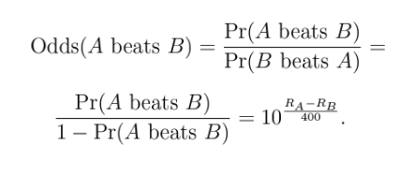
If the Elo ranking of player A is 400 points greater than that of opponent player B, then Player A should be 10 times more likely to win the game, according to Arthur Berg [5].
Fig.1 Elo Formular by Arthur Berg [5]
The Equation above can be solved to provide a probability of A proceeding in a game with B ending in three possible outcomes. (Win, lose or draw) The scope of this thesis is not focused on the Elo ranking, but it should be noted that this is one of the contributing (columns) factors in the anomaly detection system created. Another very key fact that is not captured in the above equation is according to Prominent Chess Players by Arthur Berg [5]: The player who plays with the white pieces, specified by the rules of chess, plays first and has been proven to have a distinct advantage over the player with the black pieces. The quantitative nature has been analysed over an extensive chess database by Arthur Berg [5].
Making space in the dataset for the prominent advantage white has could potentially improve the rating system and anomaly detection of the machine learning system. Regardless, such an addition does not predict that whites would win even on an equal rating with blacks. In the rating range of 200 to 2900, there is a 35% to 55% chance that the game will end in a draw.
With the help of my algorithms, I correctly detect anomalies in a chess dataset that includes games where a foreign chess engine was used to gain an unfair advantage.

1.6 MOTIVATION OF THE STUDY
My biggest drive to complete this is not only because I enrolled to become a Master of Data Science and Analytics, my background in creative media, and my college degree in games development but also because I find great joy in gaming, competing online and developing skills in various online mediums as long as the said medium is fun and fair. I have encountered my fair share of cheating, the use of exploits and the blatant disadvantage of competing against a player who has an unfair edge over another player. As our world moves closer into a world where online connections are valued almost as well as in-person connections, I believe it is just right to ensure such online spaces are not ruined by cheats and exploits, and to do so, we have to do groundbreaking research into these fields to ensure their integrity and our continuous usage. In the case of video games and, more specifically, chess, I hope to find efficient, reliable and quick ways to protect the integrity of every player on this platform. This thesis is my first step.

1.7 CHAPTER SUMMARY
This chapter introduces the premise of my thesis on anomaly detection and the use of unsupervised algorithms to pick out cheating in datasets. The reason for the occurrence of this thesis is not only to make the space for cheating in video games more accessible but also to create an applicable algorithm which could be used to detect anomalies in online video games, more specifically chess.

2. LITERATURE STUDY/REVIEW

2.1 INTRODUCTION
To the best of my knowledge, other researchers have not carried out any work in this area of study. Still, similar research in various fields either used an anomaly detection algorithm or explored anti-cheating applications and systematic review of anti-cheating, anomaly detection and unsupervised algorithm applications. During the project development, knowledge had to be pulled across various fields of study and adjusted to guide my research. A major hurdle encountered during this process is the limited availability of online multiplayer games with a database of cheats and official applications or documentation of anti-cheat software and algorithms.
Above are a few applications of anomaly detection applications; various algorithms can be used to achieve said task, but in this thesis, the algorithm of use would be K-means Clustering and Isolation forest for reasons provided prior.

2.2 REVIEW OF EXISTING PAPERS
Luca Galli et al. [10] proposed a three-system component to solve the threat of cheating in online multiplayer games, specifically in Unreal Tournament III. The authors created a framework that utilised supervised machine learning techniques to detect cheating behaviours automatically. The framework consists of three main components:
- Extended Game Server: Collects relevant game data such as player positions, aiming angles and weapon usage.
- Processing Backend: Preprocesses the collected data and applies machine learning models to detect cheating behaviours.
- Analysis Frontend: Provides a user interface for real-time monitoring and offline analysis.
The paper details the experimental setup, collection of the dataset and the application of five supervised machine learning techniques, which are decision trees, Naïve Bayes, random forests, neural networks and support vector machines. All techniques achieved high accuracy in detecting cheating behaviours with Naïve Bayes and support vector machines performing better than the rest. Something of note from this experiment by Luca Galli et al. [10] is the occurrence of false positives, which became an issue, especially in the case of support vector machines. The authors demonstrated the effectiveness of machine learning in detecting cheating behaviours in online games but noted the need for refined frameworks and the use of more advanced machine learning techniques to improve accuracy further and reduce false positives in detection.

Haapaniemi Heikki [11] conducted an in-depth systematic review that dove into the prevalent issue of cheating in video games, examining various forms, impacts, and potential countermeasures. The paper explored the specific challenges posed by cheating in different gaming contexts, including multiplayer, single-player, esports and speedrunning. A comprehensive review of cheating methods is also presented, categorising them based on their level of operation (game, client, network, server, and real world) and their underlying techniques (memory manipulation, automated bots, and social engineering). Additionally, the paper discusses the evolution of cheating methods over time, with the inclusion of machine-learning-based cheating. The paper then turns to the realm of anti-cheating methods, examining various approaches to detect and prevent cheating. With various classifications, such as local, severe-side, and network-based categories. The paper touches on the key anti-cheating techniques for each classification layer:
- Client-side: Secure software design, tamper detection, and anomaly detection.
- Server-side: Data analysis, machine learning, and behavioural analysis.
- Network-based: Secure communication protocols, packet inspection, and intrusion detection.
The paper emphasises the ongoing battle between cheaters and anti-cheat developers as the arms race with cheaters. Although it points out that significant strides have been made in the detection and prevention of cheating, the emergence of new techniques and the constantly evolving nature of gaming platforms continue to pose challenges to anti-cheat developers.

The paper by Greige Laura [12] focused on the detection of cheating and malicious behaviour in competitive multiplayer games, which was perfect for the review according to this project. The writer Greige proposed a novel approach based on machine learning techniques to identify anomaly behaviours and patterns that deviate from legitimate gameplay. Before going into the key contributions of this paper, one key concept of this paper stuck out. It was the indication that ‘Smurfs’ performed as outliers similar to cheaters. It was a clear indication of false positives, which is a recurring theme in anti-cheat detection. Smurfs are players who have a higher skill level or higher Elo rank but create a new account to play at a lower skill level than they can actually perform at. It has been noted that these players do this for various reasons, but the prominent ones are either to accomplish a feat that would have been highly unlikely against equally skilled players. For example, they may attain a certain amount of kills in a limited time against other players or level up a new account as a challenge to themselves. Regardless of the reason, these outliers could show false positives and give a false sense of a better-performing algorithm. The Key contributions of the work of Greige Laura [12] are:
- Adaptive Defensive Strategies: The paper introduces a deep reinforcement learning-based approach to develop adaptive defensive strategies against network intrusions. A concept shared by Haapaniemi Heikki [11] in the statement about Network-based intrusions to facilitate cheating. Greige Laura [12] proposes a strategy to enable the system to learn and adapt to evolving attack patterns. Involves the use of historical data and an adaptive approach.
- Resource-Efficient Defensive Strategies: The author proposed a cooperative game-theoretic framework to optimise resource allocation and improve the efficiency of defensive mechanisms. Applying game theory, they could model an interaction between defensive mechanisms as a cooperative game. The framework work would help optimise strategies, facilitate cooperation and improve efficiency by reducing redundancy and optimising resource utilisation.
- Generalized Cheater Detection: A generalised anomaly detection system is presented to identify a wide range of cheating behaviours, including collusion and smurfing, both of which are traits of highly skilled players. Collusion is much more easily spotted as both teams would find ways to balance their wins and losses by exchanging losses and wins. The system analyses player behaviour patterns and flags suspicious activity without relying on specific cheating techniques.
The methods proposed were evaluated on real-world game data, demonstrating high accuracy in detecting cheating and smurfing behaviours. Greige Laura proposed a generalised detection system that incorporated more advanced machine learning techniques and could challenge the ever-evolving cheating methods.

Anomaly detection is a field that has been studied rigorously and implemented to solve various and often specific needs. Anomaly detection has been applied to various fields, and more often than not, they are used specifically for certain applications, as proven by Ali Bou Nassif et al. [4]. Examples of fields in which anomaly detection is applied are not limited to cyber intrusion detection, fraud detection, medical anomaly detection, industrial damage detection, image processing detection, textual anomaly detection, traffic anomaly detection, textual anomaly detection, sensor network, surveillance anomaly detection and text anomaly detection according to Ali Bou Nassif et al. [4]. Anomaly detection in discrete sequence and symbolic sequencing has also been a forthcoming application. The application of anomaly detection in often specific domains includes clustering techniques to detect anomalies in various fields.

An aspect of the usage of anomaly detection applications that has to be taken note of is the different models, classification algorithms, application techniques, problem domains, approaches and methods of usage. According to Zuo [5], in a survey of the three most prominent applied techniques of anomaly detection in the field of geochemical data processing, Fractal/multi-fractal models, compositional data analysis, and machine learning (ML), although the writer zones in on the use of machine learning techniques.
The surveyed framework of log-based anomaly detection by He et al. [6] reviewed six representative anomaly detection methods, evaluating each subsequent one. The Writer compared and contrasted the precision and effectiveness of two representative datasets in the production log.
In the space of anomaly intrusion detection systems, Yu [7] proposed an extensive study on anomaly intrusion detection techniques, which are statistical, machine learning, neural networks and data mining detection techniques.

2.3 CONCEPTUAL REVIEW

2.3.1 K-MEANS CLUSTERING
K-means is an unsupervised clustering analysis algorithm that is based on vector quantisation, which groups objects or partitions n observations based on their feature values or K clusters. K in K-means stands for the designated number of clusters (must always be a positive integer) that must be inputted before the algorithm begins processing.
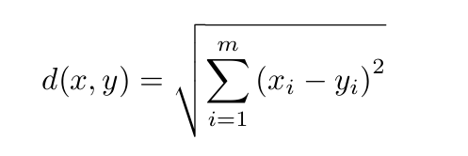
K means requires a distance function in order to begin processing. The most used distance function is the Euclidean, which can be defined as:
Fig.2 Euclidean formula by Gerhard Munz et al.

Where x = (x1,…,xm) and y = (yi,…,ym) are two input vectors with m quantitative features Gerhard Munz et al. [8]. In using the Euclidean distance function, it can be said that all features contribute equally to the function value in one way. This poses a problem when each feature is measured with different metrics or scales (for example, distance and volume are valued differently). The features would have to be normalised before the distance function was applied to overcome this.
Another distance function is the Mahalanobis distance function. This uses the inverse covariance matrix. $S^{-1}$to show statistical correlations between different features by Gerhard Munz et al. [8]:
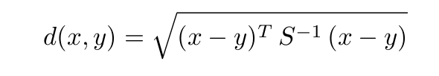
Fig.3 Mahalanobis formula by Gerhand Munz et al.
Below are the key steps of the K-means algorithm:
- Define the specific number of likely clusters K.
- Set hyperparameters for the K-means algorithm
- To initiate the K-Means clustering process, we must first initialise the positions of the K cluster centroids. This can be accomplished by randomly assigning data points to K clusters and calculating their centroids or directly selecting K distinct data points as initial centroids. Ensuring that no two centroids coincide is essential to prevent clustering errors.
- To iterate the K-Means clustering process, we calculate the distance between each data point and every cluster centroid. Each data point is assigned to the nearest cluster centroid based on these distances. This step effectively groups similar data points, forming distinct clusters.
- Recalculate the centroids of both modified clusters.
- Repeat step 3 until the centroids do not change anymore.

2.3.2 ISOLATION FOREST
An Isolation Forest, an ensemble learning method, is a binary tree where each node has two or no child nodes. To create an Isolation Tree, a random attribute and a random split value are selected to divide the data into two subsets. This process recursively applies to each subset until certain conditions are met, such as reaching a maximum tree depth or having only one data point in a node.
The basic idea of iForest is the ability of the iForest to separate anomalous data in a dataset from the rest of the dataset provided.
Isolation Forest isolates data points recursively by randomly selecting features and split values. This process results in a tree-like structure, where anomalous data points are typically isolated with fewer splits. The path length to an anomaly is shorter compared to standard data points, indicating their deviation from the general data distribution.
Anomaly detection using Isolation Forest is based on the principle that anomalies are often isolated points that can be easily separated from expected data points. By measuring the average path length required to isolate a data point, the algorithm can identify anomalies as those that are isolated with fewer splits.
Before getting into the mathematical expression of the isolation forest, some interesting notes about Isolation forest stood out in my research into this algorithm.
Isolation Forest, also known as iTree, can identify anomalies as points with shorter path lengths, and they also establish trees that take the role of ‘experts’ to target different anomalies. It is reported by Fei Tony Liu et al. [9] that isolation forest can function well on smaller sample sizes, which is contrary to existing methods where a large sampling size is more desirable. According to Fei Tony Liu et al. [9], an anomaly score is required for an anomaly detection method, which is difficult to derive. Path length, which helps in deriving the anomaly score, is measured as such: the number of edges X measures Path Length h(x) traverses an iTree from the root node until the traversal is terminated at an external node quoted from Fei Tony Liu et al. [9]. A point of note is that the Isolation Forest bases its function on the anomaly score, and an interesting extract is the influence each feature has on the overall anomaly score.

2.3.3 ANOMALIES
Anomalies, also called outliers, are data points or observations that deviate irregularly from the expected or normal perceived behaviour within a specific dataset. These irregularities can be caused by numerous factors that include but are not limited to wrongly collected data, system malfunctions or fraudulent activities. This thesis focuses on the latter, fraudulent activities in the case of cheating in video games that expose and exploit weaknesses in the video game security system.
Anomalies are classified into three main categories:

POINT ANOMALIES
These are individual or data points significantly different from the overall data. An example might be a 20-foot-tall human in a dataset of human heights, categorised as an anomaly. This is also regarded as the simplest anomaly form.

CONTEXTUAL ANOMALIES
Data points are viewed differently depending on the dataset in which they exist. A data point is anomalous in a specific context, but in another context, it is called a contextual anomaly. Contextual anomalies carry two attributes: contextual attributes and behavioural attributes.
Contextual attributes are applied to understand an instance's relationship to the dataset around it. For example, the address of a location is a contextual attribute in locational datasets. The behavioural attribute focuses more on the non-contextual features of an instance. Using my previous example, the figure of the house number in an address in a particular locational dataset could describe and add to the general number of households in that specific location.

COLLECTIVE ANOMALIES
If a set or a collection of data points in a dataset are anomalous for the entire dataset, it is called a collective anomaly.
Machine learning techniques are increasingly used as one of the best approaches to detect anomalies in various sectors and domains. Machine learning is the effort to “automate the process of knowledge acquisition from examples” by Albery B. Jeng et al. [13]. Anomaly detection can be split into three broad classes:

SUPERVISED ANOMALY DETECTION
Supervised anomaly detection methods typically involve training a classification model on a labelled dataset, where instances are categorised as "normal" or "abnormal." This model then classifies new, unseen data points based on their features. However, the primary challenge with this approach is the requirement for large, accurately labelled datasets. In many real-world scenarios, especially within the video game industry, acquiring and labelling such datasets can be prohibitively expensive and time-consuming. This makes it impractical for many game developers and security teams to implement such techniques.

SEMI-SUPERVISED ANOMALY DETECTION
Semi-supervised techniques offer a more practical approach to anomaly detection in video games by leveraging large amounts of unlabelled gameplay data and a smaller set of labelled anomalous behaviours. This approach is particularly advantageous in real-world gaming scenarios where abundant standard gameplay data is readily available while anomalous behaviour, such as cheating or hacking, is relatively scarce. However, a key limitation of semi-supervised techniques in the context of video games is the assumption that the unlabelled data is entirely composed of normal gameplay. If this assumption is violated, and the unlabelled data contains even a tiny proportion of anomalous behaviour, the model's performance may be compromised.

UNSUPERVISED ANOMALY DETECTION
Unsupervised learning techniques, which do not rely on labelled data, are desirable for anomaly detection in video games due to the scarcity of labelled anomalous behaviour. By analysing unlabelled gameplay data, these models can identify patterns and anomalies that deviate from normal behaviour in video games. However, a significant challenge arises from the inherent nature of unsupervised learning. Since these models are not explicitly trained to recognise specific types of anomalies in video games, they may identify outliers that are simply noise or irrelevant variations in gameplay rather than genuine instances of cheating or hacking in video games. This can lead to false positives and reduced detection accuracy in video games.
Anomaly detection is an explored topic in machine learning, with numerous research papers exploring various techniques. However, most of these techniques have been developed and evaluated within specific application domains, limiting their generalizability to other domains. A study of anomaly detection techniques by C.C Michael et al. [14] working in various domains differs from one domain to another. So, if applying an anomaly technique is effective in a specific domain, reapplication in another domain may not yield similar results.

2.3.4 CHEATING & ANTI-CHEAT METHODS

DEFINITION OF CHEATING
Online multiplayer video games have revolutionised the gaming industry, fostering increased player interaction and competition. However, this shift has also introduced new challenges, particularly in the form of cheating. Cheating in online games has become a significant issue, with various techniques used to gain an unfair advantage. These techniques can range from simple exploits to sophisticated hacks, undermining the game's integrity and negatively impacting other players' experience.
In the case of online chess, the integrity of the game has become increasingly questionable, especially in competitive settings where prize money is involved. Cheating in online chess can take many forms, such as using computer assistance or colluding with other players. This gives cheaters an unfair advantage over their opponents, undermining the principles of fair play and skill.
In general, cheating in online multiplayer video games, including chess, is defined as any behaviour or interaction with the online platform that gives a player an undeserved or unfair advantage that they are not entitled to under the game's rules.
Such definitions have shortcomings that often sound ambiguous and cover many areas that some might not consider “cheating”. Unfair advantages might also cover areas where players have technological advantages in terms of better hardware or internet connection speed. Such definitions also limit the idea that players consider the game to be played in one manner, and the developers believe the game to be played in another manner.

CHEATING IN ONLINE MULTIPLAYER GAMES
Online platforms like Steam, Xbox Live, and PlayStation Plus are among the various platforms on which players can interact with each other. These platforms make use of the internet. Cheating as regards a single player can not be compared to multiplayer, as in the case of a single player, no other person is unwilling to be subjugated to another player with an unfair advantage. In the case of multiplayer games, various players are reluctant to be subjugated to one exploit or another; these experiences, more often than not, become a negative experience, which reduces the integrity of the game. In a competitive game of chess, when a player with a lower rating uses some form of exploit to win against another player, it reduces the reliance and trust in the Elo ranking of players. Also, players would be more likely to lose faith in the platform. Attempting to find a much more secure and trustworthy platform reduces player retention in such platforms. The reputation of such a platform is tarnished, and the revenue generated from said platform is more likely to drop.
Online multiplayer games are a prevalent subject in analysing and researching anti-cheat and cheat creation. The sales of cheating tools, exploits, and cheat exploits generate sensible revenue, incentivising constant development and continued research in the field.

CHEATING IN ESPORTS
Esports, also known as electronic sports, are a monetary incentivised competitive environment where players who have committed a large part of their time to gain a higher level of mastery in the said game compete against other higher calibre players in team format or otherwise while in a strict format in other to gain a form of reward be it a trophy or a prize money most often both. In the settings of esports, cheating is less prevalent even though the environment is online multiplayer; there is a higher level of scrutiny and monitoring in real-time, which inhibits players from using exploits, primarily when such contests are held in a physical environment. Such monitoring reduces the occurrence of cheating, leaving it rare. Regardless of the incentives to cheat in esports, cheating in this space is much less prevalent and less relevant to this thesis, as cheating in chess contests is a very rare and highly disputed occurrence.
Cheating exists in various classification layers. The scope of this thesis is focused on the client layer and anomaly detection, so other subsequent layers will not be mentioned from this point onwards. However, such information was deemed noteworthy in providing an overall scope of cheats and the layers on which they exist.

Table I: Layers used by different sources [11]…
(Ki et al., 2004) | (GauthierDie key et al., 2004) | (S. Webb et al., 2007)  (S. D. Webb & Soh, 2007) & (S. Webb & Soh, 2008) | (Lan et al., 2009) | (Jeng & Lee, 2013)
Client Layer | Game | Game Level | Client | Game Level
Server Layer | Application | Application Level | Server | Application Level
Network Layer | Protocol | Protocol Level | Network | Infrastructure Level
Environment Layer | Network | Infrastructure Level | Real World

Client layer cheats are malicious software or modifications to a game client that exploit vulnerabilities in the game’s software or data, such as bugs and breaking rules or terms of service.

2.4 CHAPTER SUMMARY
The chapter reviewed previous works in the field of anomaly detection and cheating. Various related papers were reviewed, including the concepts related to the thesis and cheating in relation to video games. After reviewing multiple related papers and establishment in the works of cheating, significant insight has pointed out that cheat and anti-cheat development is an ongoing battle, and both parties rely on secrecy and constant development to overcome the other. It is worth noting that there have been various applications of anti-cheat development outside the confines of the game developers whose anti-cheat engines are shrouded in secrecy; research in the field shows progress and diversity in solving the problem but still note the resurgence of cheating in said space.

3. RESEARCH METHODOLOGY

3.1 PROPOSED APPROACH
The exact date on which anti-cheat programs were first introduced into the gaming system can not be fully established. However, one can realistically trace the emergence of dedicated anti-cheat measures in the early 2000s, when games like Quake became prevalent. ‘PunkBuster’, a product of Even Balance Inc., was bundled with game clients, which prevented the application from being uninstalled. The application hid the game client process and monitored the virtual memory space. The anti-cheat program became widely used to avoid cheats and bots, which ruined the integrity and competitiveness of the game for the players. Over time, other game developers created specified anti-cheat applications for their games before this was the case. ‘PunkBuster’ was the most used Anti-cheat application. It functions primarily by checking/scanning the memory contents of the local PC for exploits; such ways can easily be averted now.
Nowadays, each game developer has developed their specific game engine (the physics inside the game) and their anti-cheat system. With the development of machine learning, it has become a must-attached weapon against cheating and a weapon to avoid anti-cheat procedures. Various applications like anomaly detection, behaviour analysis, and pattern recognition are some of the applications of ML in detecting cheaters. These ML models can identify unusual patterns that deviate from normal gameplay and analyse player interactions, communication patterns, and in-game decisions to detect suspicious behaviour, aim botting, wallhacking and speed hacking, among a few.
This thesis focuses on anomaly detection, specifically in detecting unusual patterns and flagged moves in a chess game dataset.
The Dataset containing all the features of the chess game set would first have to be cleaned and normalised. Once all the features are extensively cleaned, missing values and null values will be handled. In some cases, the missing/unknown values could be retrieved by investigating the known values, especially if the data point is Missing at Random (MAR). Upon cleaning and adjusting the missing data, the next point would be to drop all invalid data points, which means they are missing and could not be investigated or adjusted as null data points. Progressing from this point would be to input the now-cleaned dataset into an unsupervised machine-learning algorithm. Hyperparameters are settings of machine learning algorithms that are not directly learned from the training data. Instead, they are set before the training begins. The proper settings affect the algorithm's response to the dataset; it can either significantly impact the performance or be the reason why the algorithm does not perform at its best.
The hyperparameters of K-means and Isolation Forest are different, with each algorithm having its own unique set of hyperparameters, except for the random state (which is common to both), which helps lock in the result of the algorithm.
Once the algorithm has been completely implemented, various ways or codes can be used to retrieve and display the result of the algorithm. Mainly with the help of the Matplot library. In K-means' case, a visual depiction of how K-means functions would show the potential for success. K-means requires a section for n_clusters, which stands for the number of clusters the algorithm requires; in this thesis, two clusters are being searched for cheating and non-cheating data.
Isolation Forest functions differently and focuses on attaining an anomaly score with a threshold that can be adjusted. Datapoints past a particular threshold are considered anomalies; specifically, for this thesis, they are considered cheats or exploits.
After accumulating this, we can make a graphical representation of the number of flagged moves it takes for white or black to be considered cheaters.

Tools and Technologies
For this thesis, this is the list of tools used:
- Google Colaboratory: Google Colaboratory, also commonly known as “Google Colab” or simply “Colab”, is a research project tool meant for prototyping machine learning models [15]. It has very powerful hardware options such as Graphic Processing Units (GPUs) and Tensor Processing Units (TPUs)[15]. Similar to the Jupyter Notebook environment for interactive programming development [15]. It is also provided as a serverless feature, which is made free, just like other G Suite products. [15]
- Python Programming Language: A free programming language that was designed in 1990 by Guido van Rossum [16]. Python, which is modular in nature, is an interpreted, interactive, object-oriented programming language [16]. It provides high-level data structures such as list and associative arrays (called dictionaries), dynamic typing and dynamic binding, modules, classes, exceptions, automatic memory management, etc [16].
- Comma Separated Value File: The CSV format has various specifications and implementations but is traditionally used to exchange and convert data between various spreadsheet programs [17]. IANA, which stands for Internet Assigned Numbers Authority, has registered a “text/tab-separated-values” type; no Multipurpose Internet Mail Extensions (MIME) types have ever been registered with IANA for CSV [17].
- SciKit-Learn: A Python module that integrates a wide range of state-of-the-art machine learning algorithms. These algorithms are used for medium to low-scale supervised and unsupervised problems [18]. The package focuses on allowing non-specialists to have access to machine learning through the use of general-purpose, high-level language [18]. Scikit-Learn, also known as SKlearn, puts a lot of emphasis on ease of use, performance, documentation and API consistency [18].
- Matplotlib: This is a Python package for plotting. It generates and produces quality graphs that come in different forms and can be easily edited with little changes in the code. Matplotlib is also designed to be used in a simplified way with few commands to create simple and complex plots[19]. Matplotlib is also written to be used alongside Numpy and other extensions code [19]. A few lines of code generate plots, histograms, power spectra, bar charts, error charts, scatterplots, etc [19]. Matplotlib as a concept is divided into three parts: Pylab interface, matplotlib, and matplotlib backend [19].
- Pandas: A versatile Python library specifically designed for data manipulation and analysis. Pandas provides a robust foundation for handling structured data, offering data structures and functions that streamline tasks such as data cleaning, transformation, and exploration. By seamlessly integrating with other powerful Python libraries, Pandas has become an indispensable tool for data scientists and analysts, enabling efficient and effective data-driven insights.

3.2 PROPOSED APPLICATION PROCEDURES

Dataset Acquisition
The availability of datasets in the gaming industry is very limited, especially when it comes to the peculiar case of datasets with games that include the use of exploits or cheating. In most cases, the researcher had to replicate similar situations that included the use of exploits or bots.
In the case of Luca Galli et al. [10], they had to create an extended game server that collected their data and created an experimental analysis involving three human players, with some using exploits. The creation of a customisable cheating system provided the team of Luca Galli et al. with a sophisticated framework from which to pull cheats. They did point out that commercial cheating systems are available. Still, these statements never included a provision of a dataset that included games with the use of exploits and one without. In their case, they created a server and a frontend system and ran games with their own created cheats to collect data from and analyse.
Greige Laura [12] proposed a more interesting mechanism for generating a unique dataset by using a Q-learning-based model Architecture. According to Greige Laura, Q-learning is a reinforcement learning algorithm that enables an agent to learn an optimal policy through iterative interactions with an environment. By learning the expected long-term reward for taking specific actions in given states, the agent can make informed decisions to maximise its cumulative reward when Q-learning is applied to the environment of Fliplt, a game of resources and capturing. They realised that the implementations were much too large and complex for Q-learning, so Deep Q-Networks was then introduced. Deep Q-Networks is used most commonly to solve games, prioritising the best action to perform in any given environment to maximise the future cumulative reward and the current map state action reward. With Deep Q-Network in place, Greige Laura could then replicate different environments and analyse the result. With Such information in hand, the researcher was able to adjust the findings of colluders (players who are on opposing teams working together) and analyse their social connections and their relationship to their ranks and ratings. It is worth noting that Greige Laura used isolation forest in the analysis.
Upon the start of this project, the acquisition of a dataset that included cheaters was difficult to come by, according to my search. It is worth noting that in the evaluation of cheating detection, public data is very limited and highly guarded. I rely on the data gathered from Kaggle (an online data repository), which is focused on collecting data sets that can be freely analysed by anyone who logs into the platform. Effectively creating an anti-cheating algorithm requires a high-quality and diverse dataset, which is not easy to come by. For my thesis to still hold true, I came upon a dataset on Kaggle.com. The dataset I found consists of 48,000 games played between bots; in each game, one or both players used either Stockfish or Maia to cheat and gained an unfair advantage. Stockfish is an open-source chess engine that optimally predicts the best move at any given moment in a chess game, while Maia is a human-like chess engine based on a neural network whose goal is to emulate the human game and human-like style. Diving deeply into the aspects of both engines is currently out of the scope of this thesis, but I would point out that Maia is in a private beta phase, and it can also be personally trained by any user on chess puzzles and can be used to play online against opponents who may or may not know such is the case. The moves are individual and, as a result, are called flagged moves; each player, be it White or Black, makes a number of flagged moves. The first ten moves of each game were sourced from lichess.org, an online database repository which contains over 6,000,000,000 as of the last quarter of 2024; lichess.org is a licensed site that allows for download, modification, and redistribution of chess game movements without asking for permission. It is the one spot to get readily available and clean chess game data. All this supporting evidence was the reason I chose to use the data provided by “BRIEUCDANDOY” for my analysis. By the standards of Kaggle, it had a rating of 10.00 in Usability, which is the highest possible score in that criteria. The dataset met all the requirements to be analysed, and Kaggle trusted it. The dataset was also released under the MIT Licence, which grants any person the ability to use, copy, modify, merge, publish, distribute, and sublicense the dataset.

General information of Dataset
The data set included seven columns of data named:
- ‘Serial number’ – number of rows in the data set
- ‘Liste cheat white’ – A series of numbers ranging from 0-1; each number denotes a move in a sequential order, with one denoting cheating and zero not cheating.
- ‘Liste cheat black’ – Essentially the same as above
- ‘Game’ – These are the movements of both black and white recorded in the Portable Game Notation (PGN) format. With the result of the game at the end.
- ‘Elo White’ – This is the numerical rating of the player that made the first ten moves for white. The Higher the number, the more skilled the player is.
- ‘Elo Black’ – Essentially the same as above.
- ‘Score’ – Result of the game. Which comes in 3 possible formats. ‘1-0’ detonates white won, ‘0-1’ detonates black won, ‘1/2-1/2’ a draw
An interesting insight to prove my data was varied in its information is shown below:
- 48,933 games
- 12,278 games have no side cheating
- 11,028 games have both sides cheating
- 25,627 games have only one side cheating
With all this information, I worked on the basis that not only is my dataset varied, but it encompasses a large and realistic pocket size of varying data that could be pivotal in the anomaly detection of my algorithms.

Dataset Wrangling
The initial stage of dataset analysis involved importing necessary libraries to facilitate effective data cleaning and preparation for subsequent analysis. Primary libraries employed for data wrangling included Pandas, NumPy, and ‘ydata-profiling’.
The data-cleaning process addressed several key issues, beginning with the normalisation of the score column. This column contained data in three formats: ‘1-0’ (indicating a win for white), ‘0-1’ (indicating a win for black), and ‘1/2-1/2’ (representing a draw). To facilitate algorithmic analysis, these categorical values were transformed into numerical representations within a newly created ‘result’ column. Specifically, draws were encoded as ‘2’, black wins as ‘1’, and white wins as ‘0’. This transformation is crucial as machine learning algorithms, being grounded in mathematical principles, operate most efficiently on numerical data. These algorithms perform computations based on mathematical equations, and numerical representations (0, 1, 2) are more readily processed by arithmetic operators (addition, subtraction, multiplication, division) compared to string representations (‘0-1’, ‘1-0’, ‘1/2-1/2’). Furthermore, the original score format could lead to misinterpretations, such as ‘0-1’ being mistakenly parsed as zero minus one rather than zero dashes one. Following this transformation, the original ‘score’ column was removed.
The ‘Liste cheat black’ and ‘Liste cheat white’ columns contained binary data (0 and 1), where zero indicated moves not flagged as potentially influenced by Stockfish or Maia, and 1 indicated the opposite. To simplify computation, the binary values within each row of these columns were summed, converting the binary representation into a decimal count of flagged moves for each player. This aggregation provided a more concise numerical representation of the flagged moves.
The ‘Elo White’ and ‘Elo Black’ columns exhibited inconsistencies. While typical Elo ratings ranged from ‘1000’ to ‘1900’, both columns also contained ‘-1’ values. Upon closer examination of the dataset and its source, it was determined that ‘-1’ represented an Elo rating one point lower than the opponent’s rating in the corresponding row. For example, if ‘Elo Black’ was 1572 and ‘Elo White’ was ‘-1’, it implied an ‘Elo White’ of 1571. To rectify this, all ‘-1’ values in both ‘Elo White’ and ‘Elo Black’ were adjusted to reflect their true Elo values relative to their opponent's rating.
The game column was dropped entirely as it only reflected the first ten moves of each game and did not contain the full move set of either black or white.

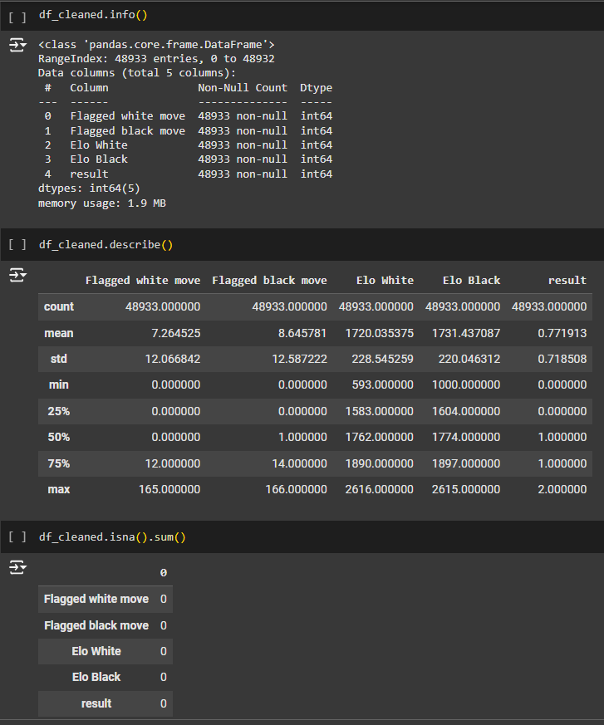
Understanding Results
Fig.4 Result of Data Wrangling.
Descriptive Statistics: The describe() function provides summary statistics:
- Counts: All columns have 48,933 non-null values, confirming no missing data.
- Means: Average flagged moves are higher for black (8.65) than white (7.26). The average Elo ratings are similar, with blacks slightly higher (1731.44) than whites (1720.04). The average result is 0.77, suggesting a possible imbalance in the outcome variable.
- Standard Deviations: Flagged moves have relatively high standard deviations (12.07 and 12.59), indicating significant variability. Elo ratings have lower standard deviations (around 220), showing less spread.
- Min/Max: The range of flagged moves is 0-165 for white and 0-166 for black. Elo ratings range from 593-2616 for white and 1000-2615 for black. The result ranges from 0-2, as expected.
- Quartiles: 75% of white players have less than 12 flagged moves.
Missing Data: The isna().sum() output shows zero missing values in all columns.

Key Observations:
- The high standard deviation in flagged moves suggests these features may be important for predictive modelling.
- The Elo rating ranges suggest a diverse skill level among the players, which could be a relevant factor in modelling game outcomes.

3.3 CHAPTER SUMMARY
This chapter details the data acquisition and preparation process for a machine learning-based chess cheat detection system. Given the scarcity of public cheating datasets, a Kaggle dataset of 48,000 bot-played games, some utilising cheating engines, was selected, supplemented with data from lichess.org for the initial moves. This diverse dataset includes Elo ratings, flagged moves indicative of potential cheating, and game outcomes. Data wrangling involved normalising game outcomes to numerical values, aggregating flagged move sequences, imputing missing Elo ratings, and removing an incomplete game record column. Exploratory analysis revealed key insights: the high variance in flagged moves suggests their predictive value, game outcome distribution indicates potential class imbalance, and the range of Elo ratings highlights diverse player skill levels as a potential influence on cheating. This rigorous data preparation provides a foundation for developing robust cheat detection models.

4. IMPLEMENTATION AND RESULT

4.1 UNSUPERVISED ML ALGORITHM APPLICATION
After thoroughly cleaning the dataset, K means clustering and Isolation Forest had to be optimised.
The first step in this process would be to tune the hyperparameters. Hyperparameter optimisation is the optimal set of hyperparameters for a machine learning model to be configured to attain the most optimal performance, accuracy, speed and ability to categorise unseen data. The combination of hyperparameter values and the correct algorithm could lead to positive results and help in maximising the potential of the machine learning model in achieving optimal results in the domain and on a specific problem.
Various algorithms have various hyperparameters, and each hyperparameter affects the model differently.
For IsolationForest, the hyperparameters set for my algorithm are as follows:
Fig.5 Isolation Forest hyperparameters.
Most hyperparameters for an IsolationForest algorithm do not need to be changed much. In the research, I found that ‘max_sample’, a hyperparameter of IsolationForest, does not require a “large amount” of samples. This is ambiguous at best, but the knowledge attained showed that I stuck with ‘900’ samples and the ‘max_features’ is at ‘1.0’, which tells the algorithm to consider all the features(as my dataset only has four features, the algorithm should consider them all the case would be different if the dataset contained more features then to prevent overfitting I would select less features to be used). The ‘bootstrap’ parameter is set as True to enable each tree to be trained on a random subset to increase diversity in the algorithm, avoid overfitting and probably improve performance. The rest of the hyperparameters are kept at default because they do not have an overly impactful effect on the algorithm.
For K Means, the hyperparameters set for my algorithm are as follows:
Fig.6 K Means hyperparameters.
K Means has various hyperparameters, but the ‘n_clusters’ is the most influential. It specifies the number of clusters to form. The K means algorithm aims to partition the data into several cluster groups, minimising the within-cluster sum of squares. In this case, a specific number of two cluster groups must be found. One is where the algorithm sees a setoff of the data as an anomaly, and the other is not. Although in the case where there might be more than two natural clusters, the algorithm would join natural clusters together, visualising the results usually helps prevent this problem. For the algorithm used within K means clustering, I stuck with auto as there was not enough evidence to prove that either ‘elkan’ or ‘lloyd’ performs better than the other at clustering for my dataset.

4.2 UNSUPERVISED ML ALGORITHM VISUALISATION & DETECTION

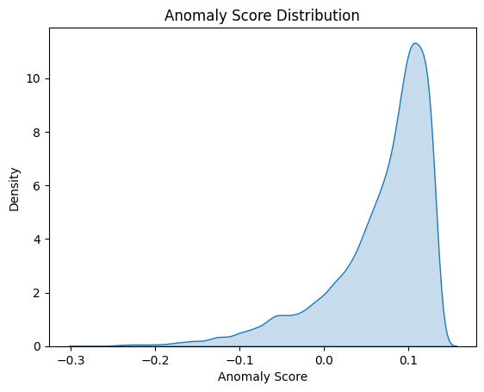
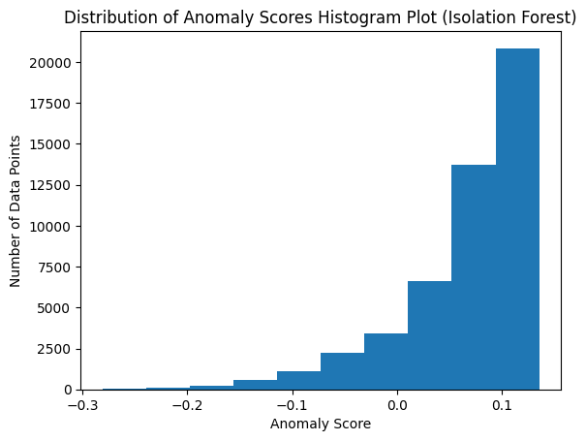
Isolation Forest Visualisation
Fig. 7 & 8 Anomaly Score Distribution for Isolation Forest.
The x-axis represents the anomaly score for Figures 7 & 8, ranging from approximately -0.3 to 0.1. In the case of Figure 7, the y-axis is the number of data points at each anomaly score, while in the case of Figure 8, the y-axis is the density of each anomaly score.
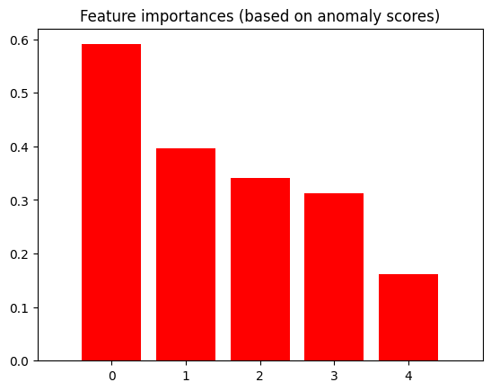
The distribution of anomaly scores is highly right-skewed; this means most of the scores are clustered around the low values (close to 0). Suggesting that most data points are considered normal with a few anomalies.
Fig. 9 Feature Importance
Feature ranking:
1. feature 0 (0.590491) – Flagged White move
2. feature 1 (0.396783) – Flagged Black move
3. feature 2 (0.340421) – Elo White
4. feature 3 (0.312327) – Elo Black
5. feature 4 (0.161520) - Result
The figures show the anomaly scores for each feature using an isolation forest algorithm. Flagged White move (feature 0) is considered the most unusual feature in the dataset. Data points that have extreme values in feature 0 are most likely to be marked as anomalies by the Isolation forest. This could mean that the Isolation forest more easily reads white moves, or the chances of White cheating as it is the first to make a move in a chess game shows it as a more anomalous move. It should be noted that according to the dataset, the White range of flagged moves is one less than the Black max range (0-165 for white and 0-166 for black).
Results (feature 4) have the lowest anomaly score of 0.162, proving that the result is not the best way to flag a cheat or find anomalies in a cheating dataset. A series of flagged moves might influence the outcome of a game, but a highly competent opponent could still win without cheating; in another scenario, both players could be cheating, and the one who cheats the least would most likely lose. Regardless, according to the isolation forest algorithm, it has the least influence on the relative outcome of detecting an anomaly.
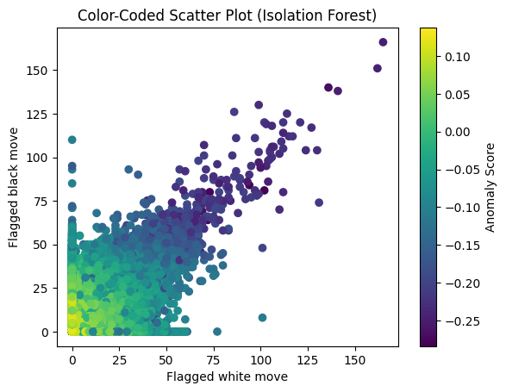
Fig. 10 Scatter Plot (Flagged black move v Flagged white move)
The Plot visualises the relationship between “Flagged white move” and “Flagged black move” in the dataset. The data points cluster in a few distinct regions, suggesting a relationship between the number of flagged moves made by white and black players. The anomaly score measures how anomalous or unusual the Isolation Forest algorithm considers a data point. Higher anomaly scores indicate that a data point is more likely to be an outlier or anomaly.
The Isolation Forest states that any flagged move above 25 on black-and-white move sets is an unusual or anomalous data point. This points to an interesting fact: each move can not rightly be predicted as an anomaly, even though it is a flagged move. The isolation Forest picks upon the accumulation of the flagged move as an anomaly.
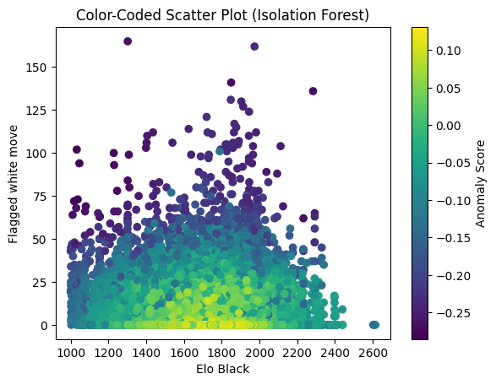
The data points with higher anomaly scores show that either white or black (or both) exhibited an unusually high number of flagged moves, which indicates cheating behaviour.
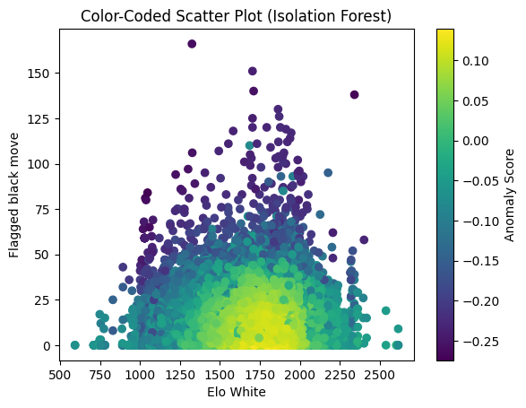
Fig. 11 & 12 Scatter Plot (Flagged move v Elo)
For both Fig.11 & Fig.12, most data points are clustered in the centre, with Fig. 12 taking on a roughly elliptical shape. This suggests that most games are between players with mid-range Elo ratings and a relatively low number of flagged moves. Points near the centre of both Figures show that mid-range Elo players tend to have a lower anomaly score and fewer flagged moves, while points towards the edge (higher or lower Elo) often have higher anomaly scores. Both Plots suggest a general relationship between Elo and flagged move regardless of which side black or white sits on.
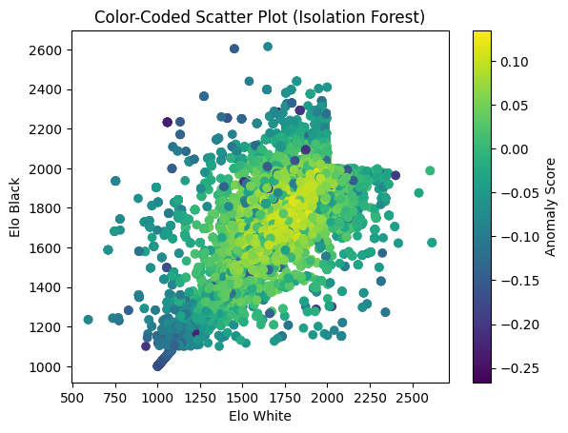
The relationship between the Elo rating and anomaly score could indicate that players with an Elo rating far from the average of either plot are more likely to cheat. This could be for numerous reasons; for example, lower-rated Elo players could be using engines to try and boost their ratings, some lower-rated Elo players could be smurfs (higher-rated Elo players) using alternative accounts to practice, and it could be higher-rated players using engines to maintain their status. It is worth noting that the count of flagged moves tends to increase with Elo rating; this could suggest a unique play style that is flagged or higher. Elo-rated players tend to cheat more, although it drops after roughly hitting the midpoint in both plots.
Fig. 13 Scatter Plot (Elo White v Elo Black)
The data points are clustered in a roughly diagonal pattern from the lower left to the upper right corner. This points to a positive correlation between the Elo ratings of white and black players; games are more likely to occur between players with similar skill levels. Points far from the diagonal (high Elo white vs low Elo black or vice versa) tend to have higher anomaly scores, suggesting these games are less common and might be considered more unusual.
The plot suggests that chess games occur between players with similar skill levels. Games where this does not occur are highlighted as unusual and less common. Various reasons could lead to said unusual occurrences; one could be a player projected to have a higher Elo rating but is currently playing on a lower Elo-rated account. The system could balance this by matching said player with a similar skill or players deliberately seeking out mismatched opponents.

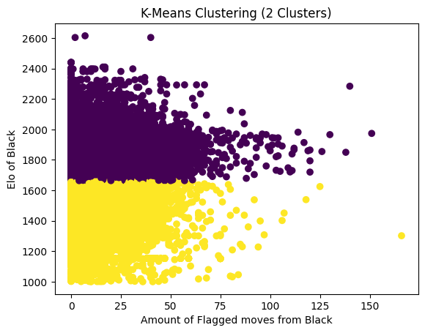
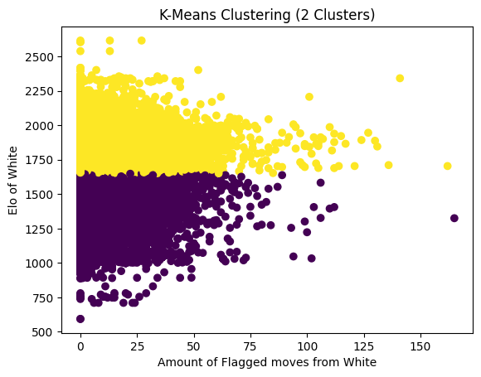
K means Visualisation
Fig. 14 & 15 K Means Clustering Scatter Plot
The visualisation suggests a weak correlation between Elo rating and the number of flagged moves in both Fig. 14 & Fig 15.
Fig 14:
Cluster 1 (Yellow): This is generally higher Elo-rated players (above the rating of 1700-1800) and a wide range of flagged moves. It focuses on capturing the higher-rated players. There also appears to be a negative correlation within Cluster 1. As the Elo rating increases, the flagged moves tend to decrease. This can be noticed more when you draw a line that best fits the data points. In this case, higher Elo players rely less on cheats as they are seasoned veterans, required to cheat sparingly in a game as they already have acquired the skills and strategy to win games.
Cluster 2 (Purple): This cluster mainly consists of lower Elo-rated players (below the rating of 1700-1800); it shows one player with 150 flagged moves, the highest in the visualisation. There appears to be a positive correlation within Cluster 2. As the Elo rating increases, the flagged moves tend to increase. This could point to lower Elo players relying on cheats as they lack the skills to win games.
Fig 15:
The results of both Figures are relatively similar, but the rating split happens between 1600-1800.

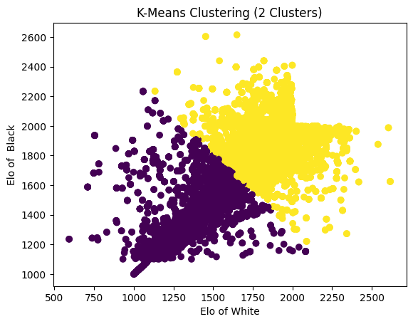
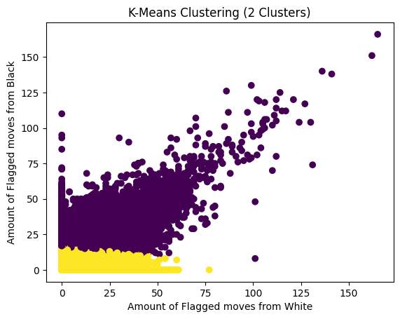
Fig.16 & Fig. 17
Both Fig. 16 & Fig. 17, when compared to their Isolation Forest counterparts, fail to convey meaningful information. This, in part, shows the limitation of K Means clustering in detecting cheating and anomalies in a chess dataset, and it also shows the prowess of Isolation Forest.

4.3 RESULTS AND FINDINGS
Both algorithms performed differently, even after the tunning of the hyperparameters.

4.3.1 Isolation Forest
The Isolation Forest algorithm effectively identified relationships between the features within the dataset, providing valuable insights for anomaly detection. Visual analysis of the results revealed key patterns and allowed for informed conclusions regarding the nature of anomalous instances.
The Isolation Forest analysis indicated that "Flagged white move" was the most significant feature for detecting anomalies, followed by "Flagged black move." This finding aligns with the expectation that flagged moves, representing potentially suspicious activity, would be primary indicators of anomalous behaviour. The model demonstrated the capacity to identify a threshold of around 25 flagged moves, above which the likelihood of a game being classified as an anomaly increased substantially. This aligns with the visualisations previously provided, which showed a darkening of data points above this threshold.
Furthermore, the analysis revealed a complex relationship between Elo ratings and flagged moves. A positive correlation was observed between these variables up to a certain Elo threshold, approximately the midpoint of the Elo rating range. Beyond this point, the correlation diminished, suggesting a shift in the observed behaviour.
This observation suggests a potential interpretation regarding using external assistance in games. Players with lower Elo ratings may be more inclined to use such assistance to improve their game outcomes. Conversely, players with higher Elo ratings rely less on such assistance and more on their inherent skill and experience. This does not preclude the possibility of cheating among higher-rated players, but it suggests that the observed patterns of flagged moves differ across skill levels. This is supported by the visualisations, which show that anomalies based on flagged moves are more prevalent at the lower Elo ratings. The mid-range Elo ratings tended to show the lowest anomaly scores.

4.3.2 K means Clustering
When applied to the chess dataset, the K-Means clustering algorithm partitioned the data into two distinct clusters based primarily on player Elo ratings. Analysis of these clusters revealed contrasting trends related to flagged moves and player skill levels.
A negative correlation was observed within the initial cluster: as the Elo rating increased, the number of flagged moves tended to decrease. This suggests that higher-rated players, possessing greater skill and strategic understanding, may rely less on external assistance or cheating during gameplay. Their acquired expertise allows them to succeed through established skills, potentially requiring only infrequent use of such assistance, if at all.
The other half of the cluster suggests that lower-rated players, potentially lacking the necessary skills and strategic knowledge, may resort to external assistance or cheating to compensate for their skill deficit and achieve more favourable game outcomes.
Comparison of the K-Means clustering results (as depicted in Figure 16 and Figure 17) with the results obtained from the Isolation Forest algorithm revealed a significant difference in their ability to convey meaningful information related to anomaly detection in this chess dataset. The K-Means clustering, primarily driven by Elo ratings, provided limited insight into identifying anomalous gameplay indicative of cheating. In contrast, the Isolation Forest demonstrated superior performance in highlighting potentially suspicious activity based on flagged moves. This comparison underscores the limitations of K-Means clustering for this specific anomaly detection task. It highlights the effectiveness of the Isolation Forest algorithm in identifying anomalous patterns within the data.

4.4 SUMMARY
Despite hyperparameter tuning, the Isolation Forest and K-means algorithms performed differently. Isolation Forest effectively identified relationships between features, highlighting "Flagged white move" and "Flagged black move" as key anomaly indicators, with a threshold of approximately 25 flagged moves suggesting anomalous behaviour. A positive correlation between Elo rating and flagged moves was observed up to the mid-range of Elo ratings, after which the correlation diminished. This suggests lower-rated players may be more inclined to use external assistance, while higher-rated players rely more on skill. Conversely, K-Means clustering primarily partitioned data based on Elo ratings, revealing contrasting trends within clusters. Higher Elo players showed a negative correlation between Elo and flagged moves, suggesting less reliance on assistance. Lower Elo players showed a positive correlation, suggesting the opposite. However, K-Means proved less effective than Isolation Forest for detecting anomalies indicative of cheating, demonstrating the latter's superior performance for this task.

5. CONTRIBUTION TO KNOWLEDGE
This analysis contributes to the current understanding of anomaly detection in the online multiplayer video game sector by demonstrating the relative effectiveness of different unsupervised machine learning algorithms for identifying potentially cheating behaviour. This case highlights the strengths of Isolation Forest over K-means clustering for this particular task.
Current online game anomaly detection methods rely on player report systems, rule-based systems, domain-specific algorithms, statistical thresholds, or basic clustering techniques. This research demonstrates that Isolation Forest, an ensemble-based anomaly detection method, offers several advantages. Firstly, it effectively utilizes multiple features (minimal features), in this case, flagged moves for both players and Elo ratings, to identify complex patterns indicative of cheating. Identifying "Flagged white move" and "Flagged black move" as primary indicators and establishing a threshold of around 25 flagged moves provide quantifiable metrics for flagging suspicious activity. Secondly, the analysis reveals a nuanced relationship between player skill (Elo) and the likelihood of cheating, suggesting that the prevalence and patterns of cheating may vary across different skill brackets. This insight is crucial for developing targeted anti-cheat measures.
The comparison with K-Means clustering underscores the importance of algorithm selection. While K-Means effectively partitioned players based on skill, it failed to provide granular insights into anomalous behaviour related to flagged moves. This demonstrates that clustering based on player skill alone is insufficient for detecting cheating, as it does not directly capture the specific actions indicative of external assistance. By directly modelling anomalies based on feature combinations, Isolation Forest proved significantly more effective in this context.
This research contributes to the field by:
- Demonstrating the efficacy of Isolation Forest for cheat detection: It provides empirical evidence of its ability to identify potentially cheating behaviour based on game data.
- Highlighting the limitations of K-Means for this specific task: It shows that skill-based clustering alone is insufficient for effective cheat detection.
- Providing insights into the relationship between skill and cheating: It suggests that cheating behaviours may differ across skill levels, informing the development of more targeted interventions.
These findings suggest that advanced anomaly detection algorithms like Isolation Forest offer a more robust and nuanced approach to identifying cheating in online games compared to more straightforward methods, contributing to the development of more effective anti-cheat systems

5.1 LIMITATIONS OF STUDY
The study's limitations ranged from my personal skills to the availability of a more detailed dataset.
The dataset provided on Kaggle does not contain many features which could have helped the unsupervised algorithm function better. According to my research, one of the variables chess.com considers when detecting fraudulent activities within their games is “Time”. Essentially, what is the average time a player takes to carry out a move, what is the value per the overall game, and how close is the move to a computer-generated move? These features could help detect fraudulent activities with a higher precision rate. Also, creating an ensemble machine learning algorithm that can make meaning of the moves made in a chess game. Chess engines have existed for years; these are sophisticated and powerful search algorithms that can evaluate functions to analyse chess positions and determine the best moves in any given scenario. Unfortunately, both K means clustering and Isolation Forest cannot make sense of chess moves in the PGN format. This is a crucial feature but must be dropped as no means of normalisation could make sense of the string data to the machine learning algorithm to the best of my knowledge.

5.2 RECOMMENDATION FOR FURTHER STUDY
For any subsequent study to be done in this sector, a much more detailed dataset is required to be able to make inferences between anomalies and standard games. An algorithm which can make sense of PGN games and the values of chess pieces. A much broader ensemble machine learning algorithm able to function in a sophisticated manner to correctly compare engine-suggested moves to player-taken moves per move in each game would be able to draw a much clearer comparison.

5.3 EVALUATION & CONCLUSION
Isolation Forest can identify anomalies based on minimal datasets. It finds unique relationships between various variables and can create a detailed inference about which flagged moves are anomalies and how often a move set must be flagged for it to be predicted as more anomalous than another. With K-means clustering, it can cluster according to the Elo ranking and flagged moves but does not perform much better on subsequent datasets.
In the case of finding cheating in chess, I can reliably say that one flagged move is not indicative of cheating; it takes subsequent flagged moves and a deep understanding of the Elo in which these flagged moves are noticed as various factors play a reason in why said moves are flagged. Elo, in combination with other factors, gives a more quantifiable reason, but it is still left to human discretion. According to my thesis, a flagged move count above 25 is an anomaly according to my Isolation Forest.

6. REFERENCES
[1] Guo Freeman (2017) Multiplayer Online Games (Origins, Players and Social Dynamics). Available at: https://doi.org/10.1201/9781315153926
[2] Jeremy Blackburn, Nicolas Kourtellis, John Skvoretz, Matei Ripeanu and Adriana Lamnitchi (2014) Cheating in Online Games: A Social Network Perspective. Available at: https://dl.acm.org/doi/abs/10.1145/2602570
[3] Panicos Karkallis, Jorge Blasco, Guillermo Suarez-Tangil and Sergio Pastrana (2021) Detecting Video-Game injectors Exchanged in Game Cheating Communities. Available at: https://nms.kcl.ac.uk/guillermo.suarez-tangil/papers/2021esorics-cheaters.pdf
[4] Ali Bou Nassif, Manar Abu Talib, Qassim Nasir and Fatima Mohamad Dakalbab (2021) Machine Learning for Anomaly Detection: A Systematic Review. Available at: https://ieeexplore.ieee.org/abstract/document/9439459
[5] Renguang Zuo (2017) Machine Learning of Mineralization-Related Geochemical Anomalies: A Review of Potential Methods. Available at: https://link.springer.com/article/10.1007/s11053-017-9345-4
[6] Shilin He, Jieming Zhu, Pinjia He and Michael R. Lyu (2016) Experience Report: System Log Analysis for Anomaly Detection. Available at: https://ieeexplore.ieee.org/abstract/document/7774521
[7] Yingbing Yu (2012) A survey of anomaly intrusion detection techniques. Available at: https://dl.acm.org/doi/abs/10.5555/2379703.2379707
[8] Gerhard Münz, Sa Li and Georg Carle (2016) Traffic Anomaly Detection Using K-Means Clustering. Available at: https://www.net.in.tum.de/projects/dfg-lupus/files/muenz07k-means.pdf
[9] Fei Tony Liu, Kai Ming Ting and Zhi Hua Zhou (2008) Isolation Forest. Available at: https://ieeexplore.ieee.org/abstract/document/4781136
[10] Luca Galli, Daniele Loiacono, Luigi Cardamone and Pier Luca Lanzi (2011) A cheating detection framework for Unreal Tournament III: A machine learning approach. Available at: https://ieeexplore.ieee.org/abstract/document/6032016
[11] Haapaniemi Heikki (2024) Cheat detection & prevention methods in video games. Available at: https://oulurepo.oulu.fi/handle/10024/48840
[12] Greige Laura (2022) Anomaly Detection in Competitive Multiplayer Games. Available at: https://www.proquest.com/docview/2732652137?%20Theses&fromopenview=true&pq-origsite=gscholar&sourcetype=Dissertations%20
[13] Albert B. Jeng and Chia Ling Lee (2013) A Study on Online Game Cheating and the Effective Defense. Available at: https://link.springer.com/chapter/10.1007/978-3-642-38577-3_53
[14] C.C Micheal and A. Ghosh (2000) Two state-based approaches to program-based anomaly detection. Available at: https://ieeexplore.ieee.org/abstract/document/898854
[15] Ekaba Bisong (2019) Google Colaboratory. Available at: https://link.springer.com/chapter/10.1007/978-1-4842-4470-8_7
[16] M.F. Sanner (1999) PYTHON: A PROGRAMMING LANGUAGE FROM SOFTWARE INTEGRATION AND DEVELOPMENT. Available at: 10.1.1.35.6459-libre.pdf
[17] Y. Shafranovich (2005) Common Forest and MIME Type for Comma-Separated Values (CSV) Files. Available at: https://www.rfc-editor.org/rfc/rfc4180#section-2
[18] Fabian Pedregosa, Gael Varoquaux, Alexandre Gramfort, Vincent Micheal, Bertrant Thirion, Olivier Grisel, Mathieu Blondel, Peter Prettenhofer, Ron Weiss, Vincent Dubourg, Jake Vanderplas, Alexandre Passos and David Cournapeau (2011) Scikit-learn: Machine Learning in Python
[19] Niyazi Ari and Makhamadsulton Ustazhanov (2014) Matplotlib in python. Available at: https://ieeexplore.ieee.org/abstract/document/6997585

7. APPENDIX
APPENDIX 1
Link to the source code
https://colab.research.google.com/drive/1Bf-gpd3RBT4h6Tow4Hk3WXk_mMIVCSDJ?usp=sharing
APPENDIX 2
Link to the data source
https://www.kaggle.com/datasets/brieucdandoy/chess-cheating-dataset/data

